Introduction
In this lab, you learn how to configure the OCI API keys. In Oracle Cloud Infrastructure (OCI), API keys are used for secure authentication when accessing OCI resources through REST APIs.
OCI API keys consist of two parts: a Public key and a Private key. You use the OCI console to generate the Private/Public key pair.
Estimated Time: 10 Minutes
Objectives
In this lab, you:
- Generate API Keys using OCI Console
- Create Web Credentials in Oracle APEX

o Generate the API Keys using OCI Console:
- Login into your OCI Account.
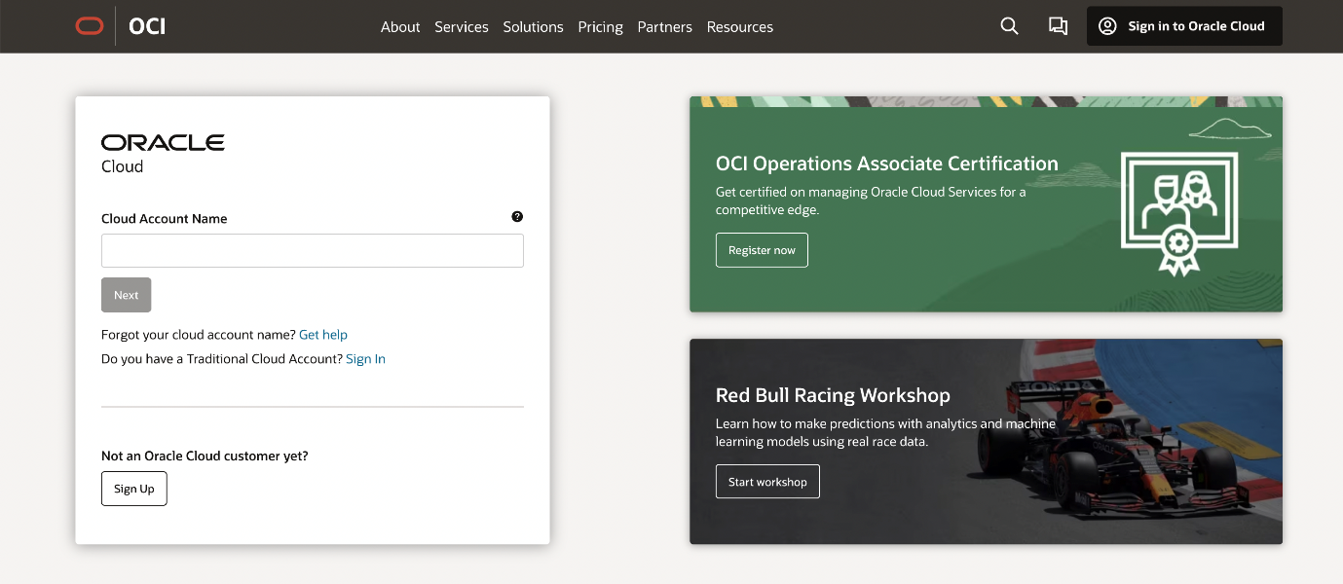
- Click My Profile at the top-right corner.
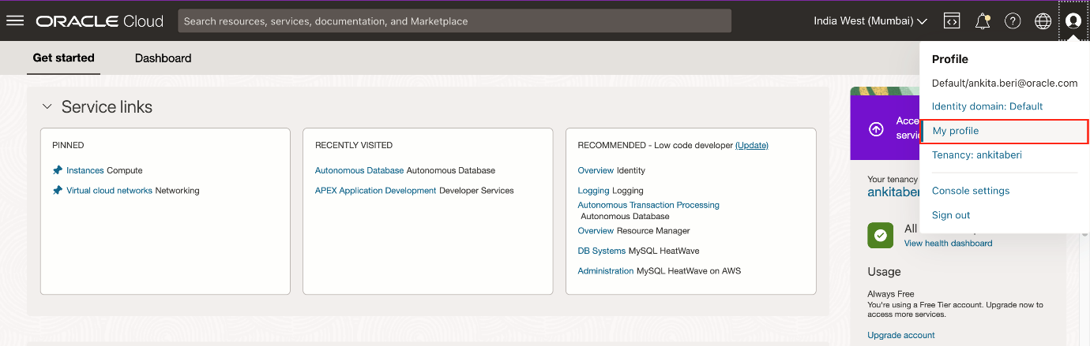
- Under Resources at the bottom-left, select API Keys and click Add API Key.
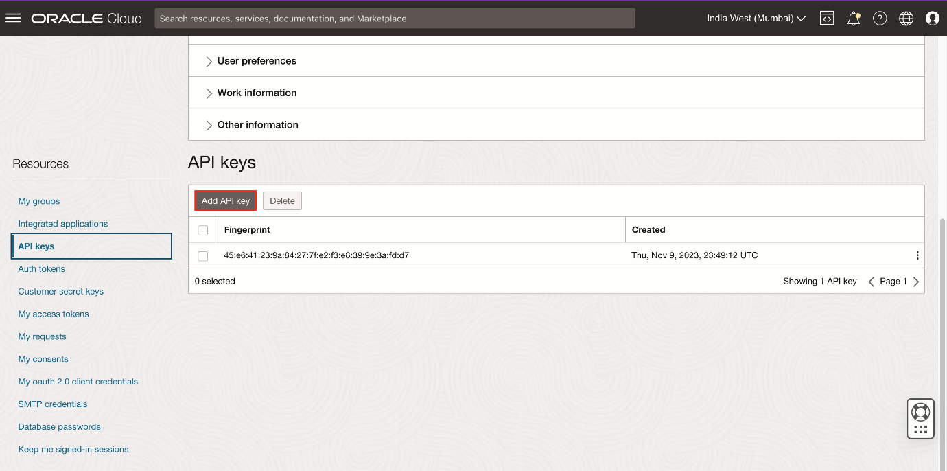
- The Add API Key dialog is displayed. Select Generate API Key Pair to create a new key pair.
- Click Download Private Key. A .pem file is saved to your local device. You do not need to download the public key.
Note: You will use this private key while configuring the web credentials in Oracle APEX in the upcoming lab.
- Click Add.
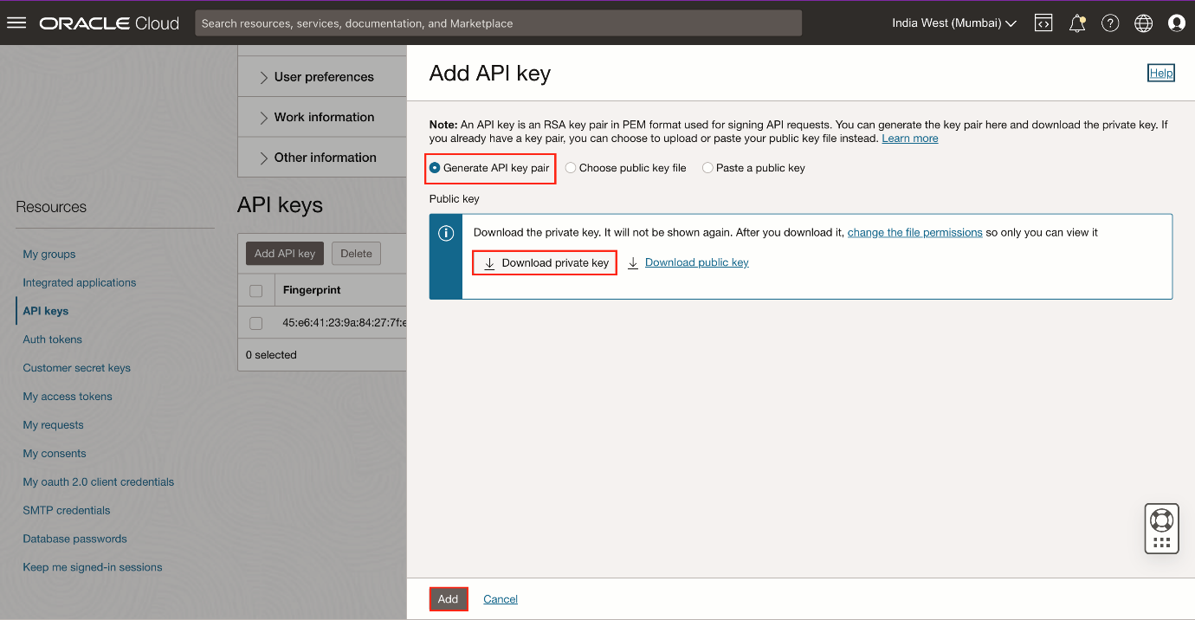
- The key is added, and the Configuration File Preview is displayed. Copy and save the configuration file snippet from the text box into a notepad. You will use this information for creating Oracle APEX Web Credentials.
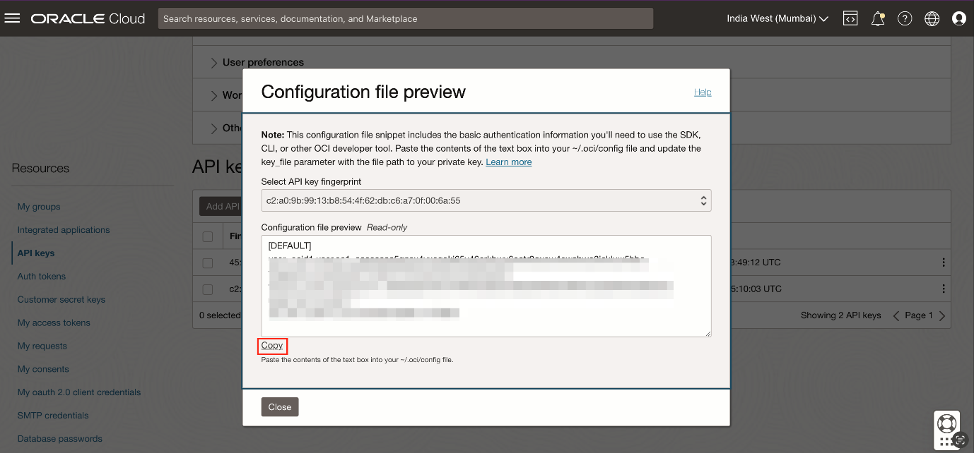
Create Web Credentials in Oracle APEX
Web credentials are used to authenticate connection to external REST services, or REST Enabled SQL services from APEX.
Creating Web Credentials securely stores and encrypts authentication credentials for use by Oracle APEX components and APIs. Credentials cannot be retrieved back in clear text. Credentials are stored at the workspace level and therefore are visible to all applications.
To create a Web Credential in Oracle APEX:
- Login into your Oracle APEX workspace.
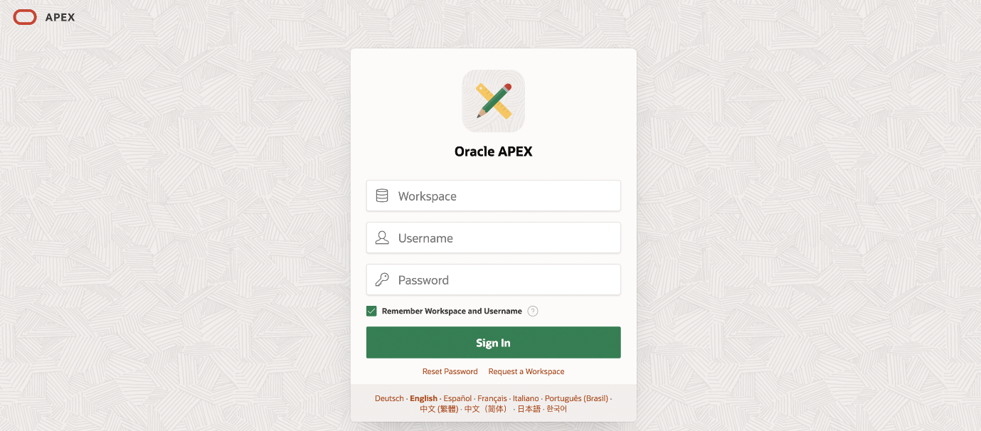
- On the Workspace home page, click App Builder.
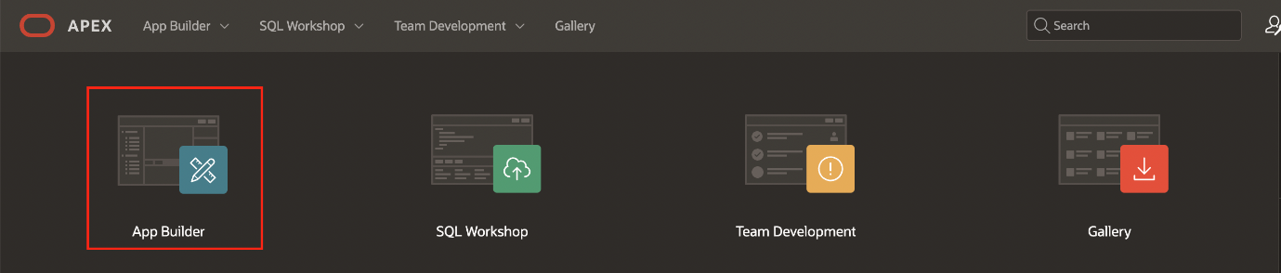
- Click Workspace Utilities.
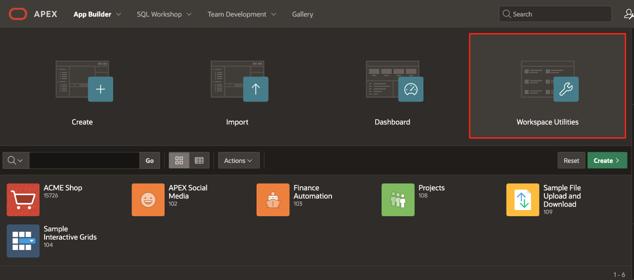
- Select Web Credentials.
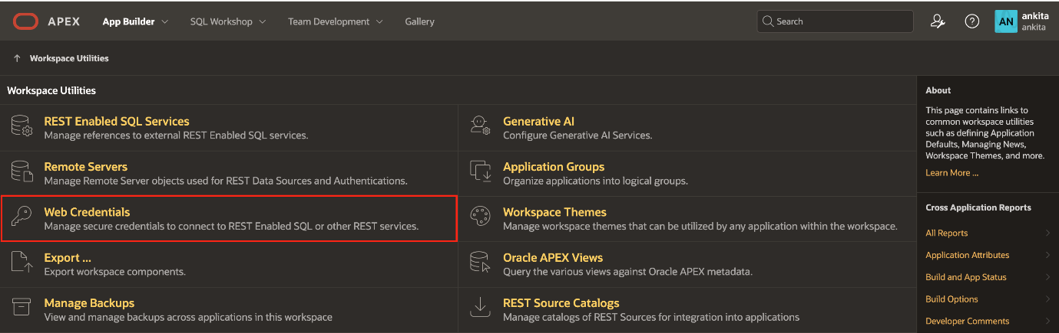
- Click Create.
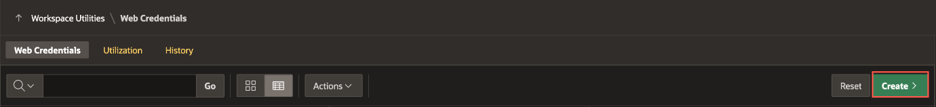
- Enter the following details using the configuration file you copied in the previous task.
  - Name: apex_ai_cred
  - Authentication Type: OCI Native Authentication
  - OCI User ID: Enter the OCID of the Oracle Cloud user Account. You can find the OCID in the Configuration File Preview generated during the API Key creation. Your OCI User ID looks similar to ocid1.user.oc1..aaaaaaaa******wj3v23yla
  - OCI Private Key: Open the private key (.pem file) downloaded in the previous task. Copy and paste the API Key.
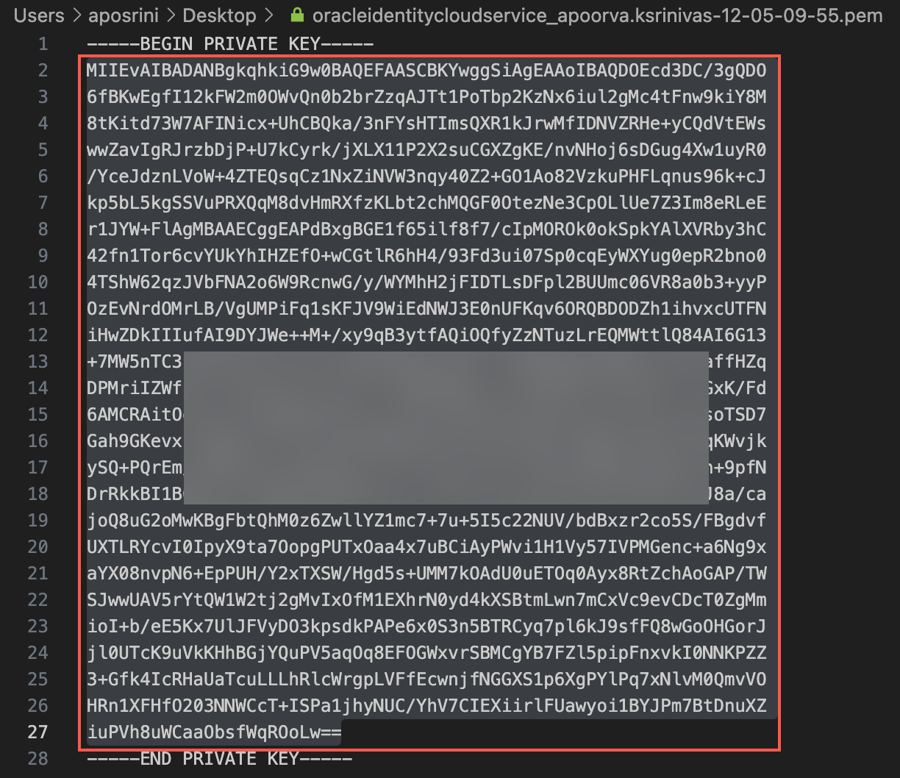
  - OCI Tenancy ID: Enter the OCID for Tenancy. Your Tenancy ID looks similar to ocid1.tenancy.oc1..aaaaaaaaf7ush****cxx3qka
  - OCI Public Key Fingerprint: Enter the Fingerprint ID. Your Fingerprint ID looks similar to a8:8e:c2:8b:fe:****:ff:4d:40
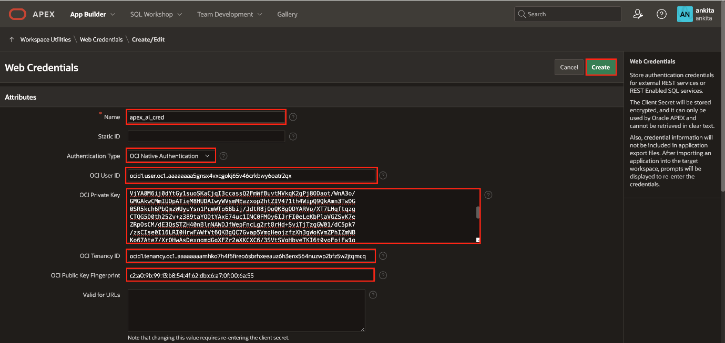
- Click Create.
- You now know how to generate API Keys using OCI console. Furthermore, you know how to create web credentials in Oracle APEX.
- You may now proceed to the next

Import the Social Media Application
Introduction
In this lab, you import the Social Media application into your APEX workspace. You use this imported app to integrate with the OCI Vision service.
You can download the Social Media Application here.
Estimated Time: 15 Minutes
Objectives
In this lab, you:
- Import the Social Media Application into your APEX workspace
- Add a Column to the Table using Object Browser to store the AI response
Import the Social Media Application
- On the Workspace home page, click the App Builder icon. On the App Builder home page, click Import.
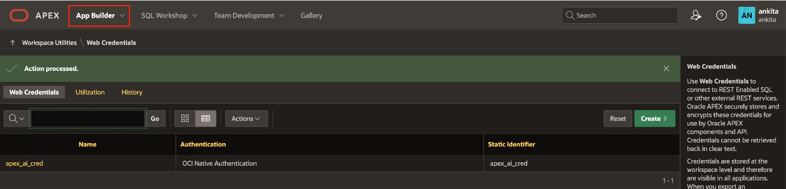
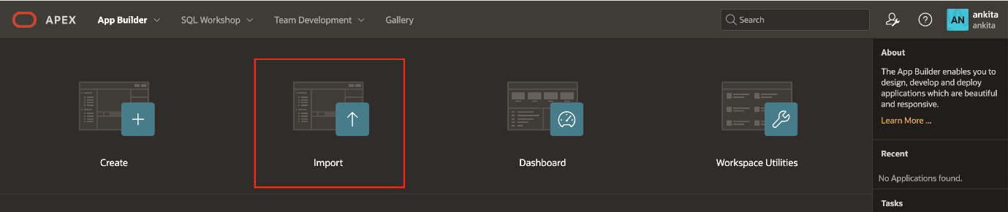
- The Import dialog displays. Download the Zip File of the APEX Social Media Application and then perform the following steps.
  - Drag and drop, or navigate to the file.
  - File Type: Indicate the type of export file to be imported. Select Application, Page, or Component Export.
  - File Character Set: Verify that the File Character Set is correct.
  - Click Next.
The export file is imported.
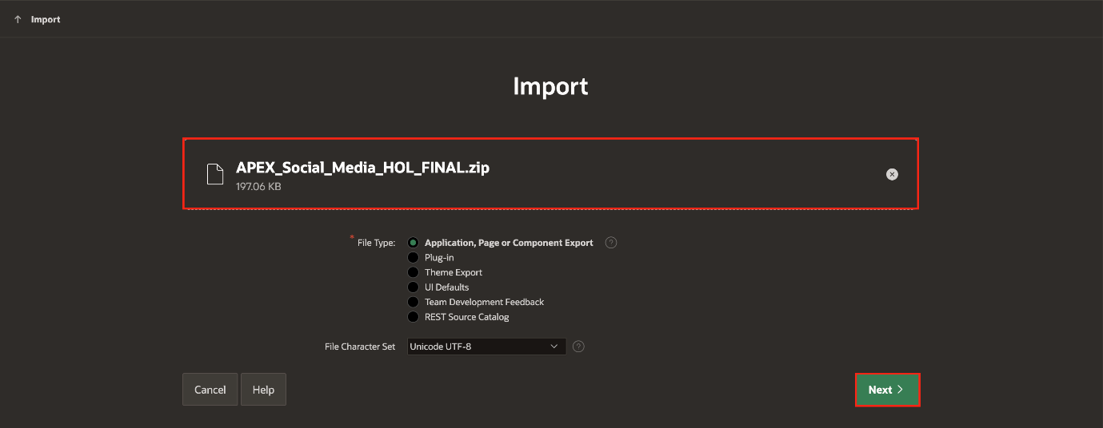
- Accept the defaults, click Install Application.
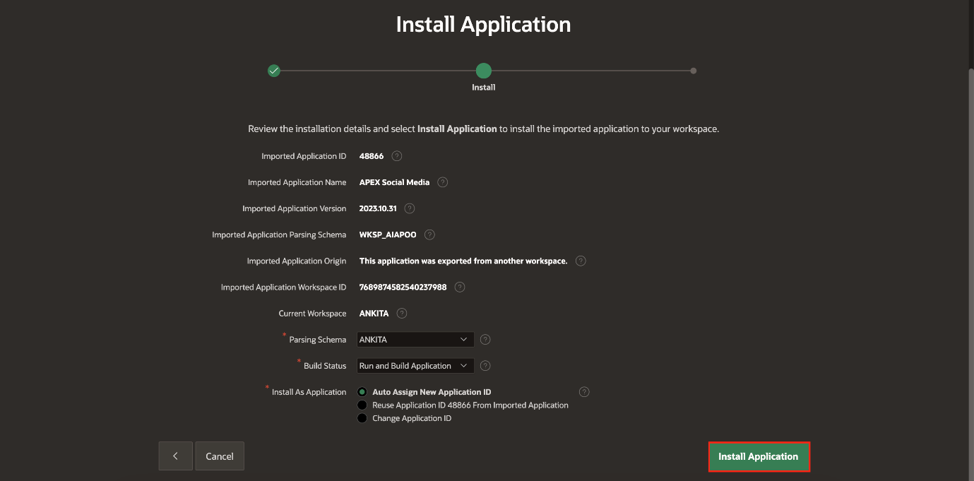
- Click Install Supporting Objects.
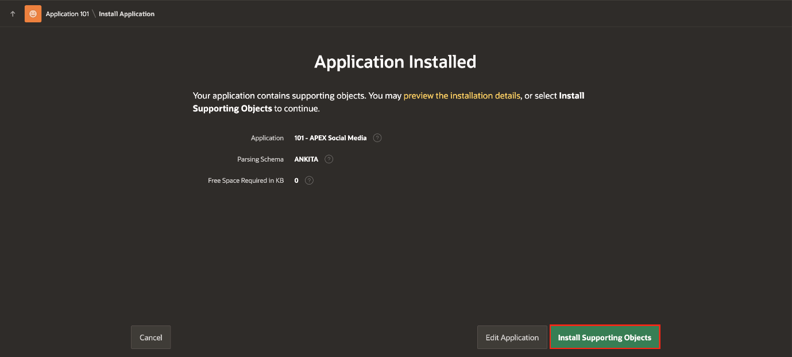
- Click Edit Application.
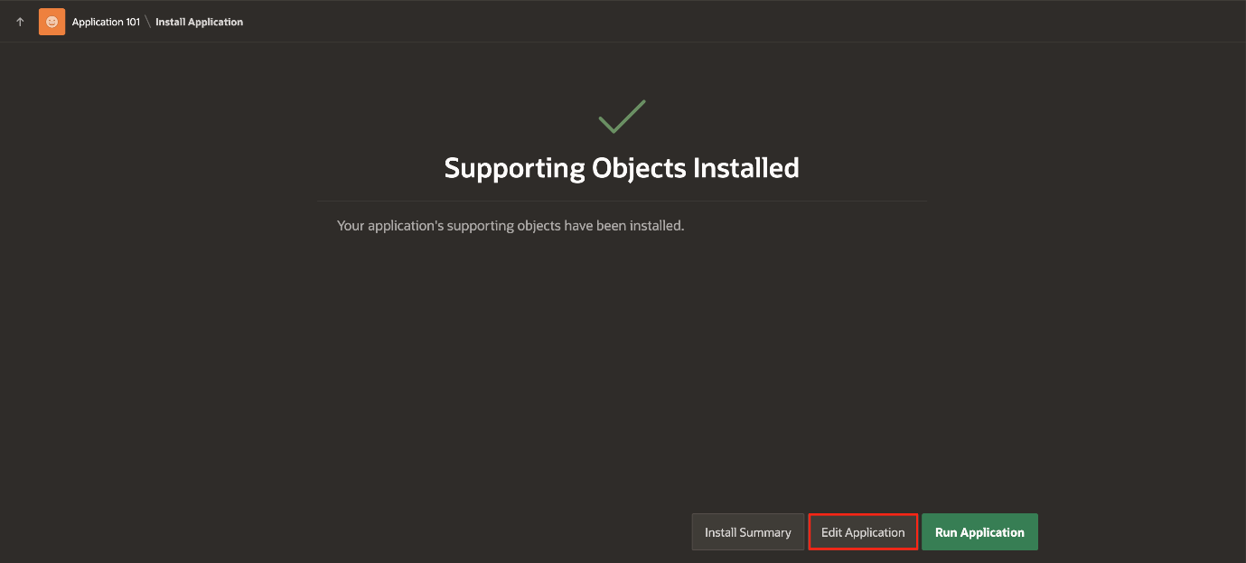
Add a Column to the Table using Object Browser
To store the output generated by OCI AI Vision service, you add a new column in the SM_POSTS Table. This addition enables you to store and retrieve the relevant information seamlessly.
To Add two new columns to the SM_POSTS Table:
- Click SQL Workshop and navigate to Object Browser.
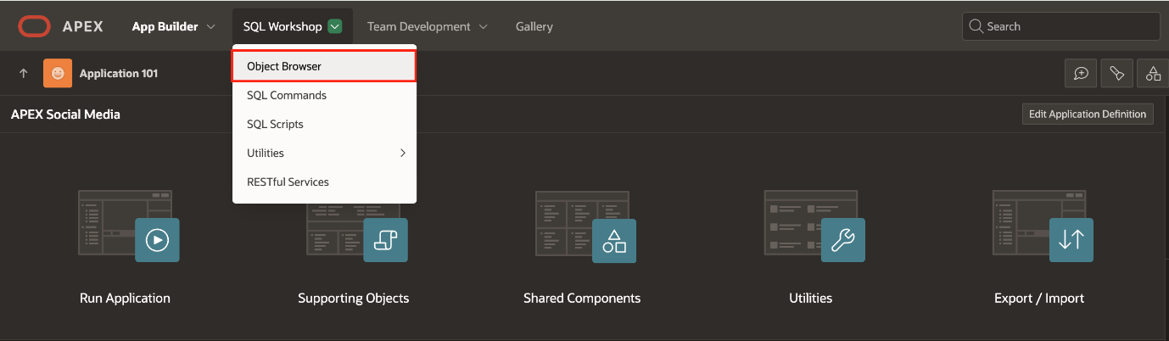
- In the object tree, expand Tables and select SM_POSTS table. On the columns tab, click Add Column.
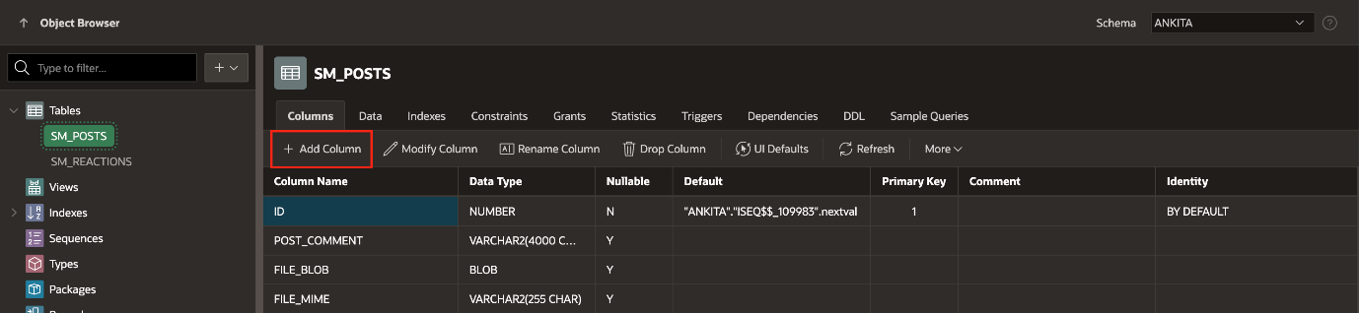
- The Add Column wizard is displayed. Configure the Add Column attributes. At a minimum, enter a column name and select a type. Depending upon the column type, specify whether the column requires precision, scale, a default value, or is nullable. For more details on an attribute, see field-level Help.
Enter the following:
  - Column: AI_OUTPUT
  - Data Type: VARCHAR2
  - Length: 1000
Click Apply.
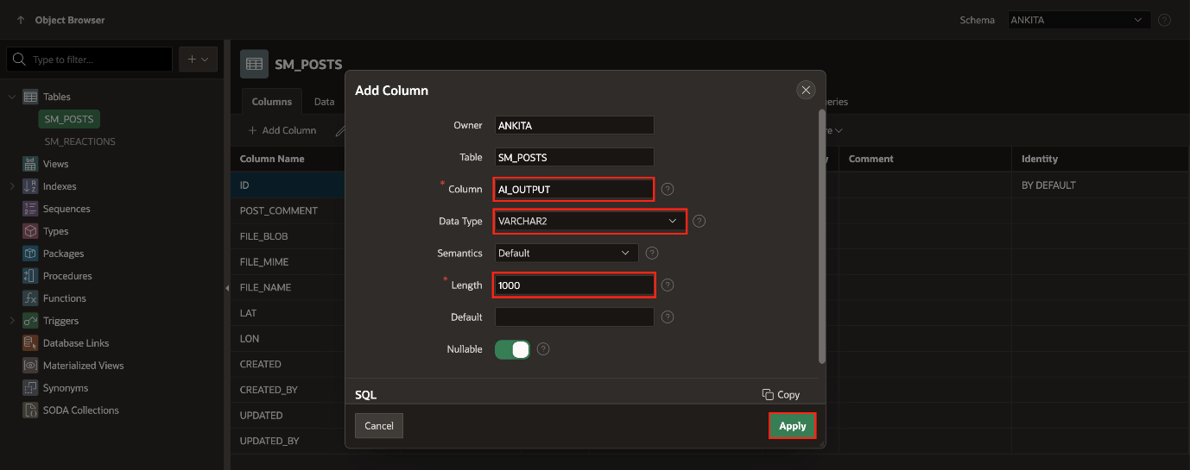
- Click Add Column and enter the following:
  - Column: AI_OUTPUT_TD
  - Data Type: VARCHAR2
  - Length: 4000
Click Apply.
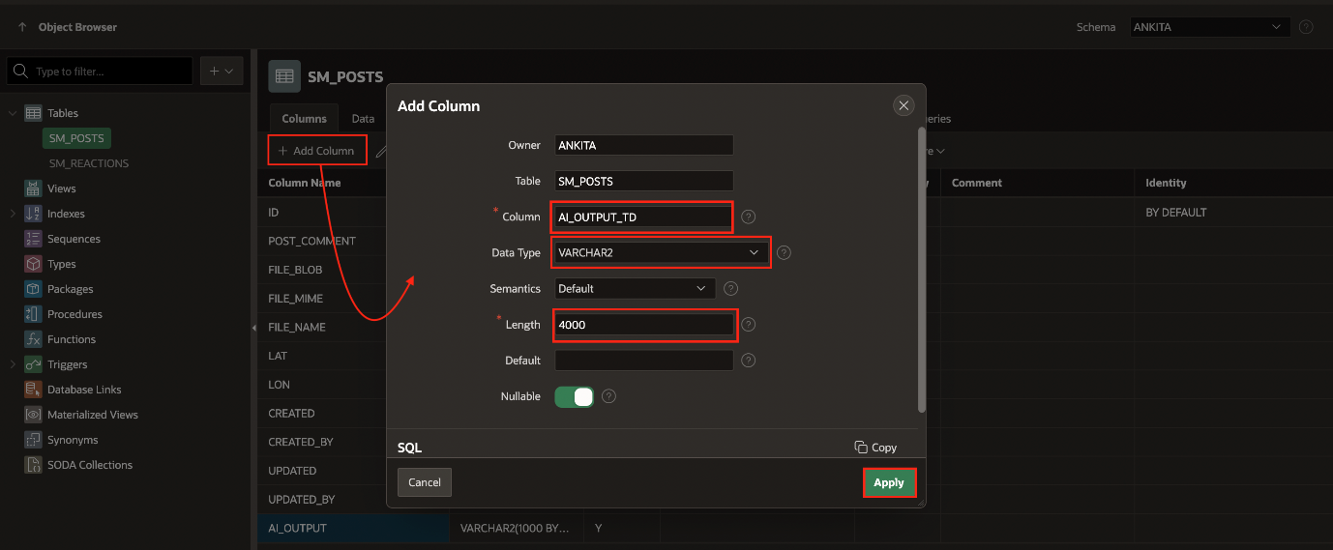

You now know how to import an Oracle APEX application, add a new column to a table.
You may now proceed to the next

